**Project report**

**WEB TECHNOLOGY**

**Project Title**

**BLOOD BANK MANAGEMENT SYSTEM**

**HTML and CSS TAGS**

**Submitted By:**

**J.PRATHIMA**

**17IT18**

**DATE:01/08/2019**

**PROJECT NAME**

Blood bank management system

**Objective**

To develop a web site for a bloodbank to serve and save lifeand save life of people.It act as an interface between Donor,receptor and blood bank.

**Admin(input)**

* Update the availability of blood group.
* Information about alternate blood
* Get the registered details
* Contact details

**User(Output)**

* Register
* Search blood
* Information about blood groups
* Add blood from blood bank

**HTML Tags**

HTML is the standard markup language for creating Web pages.

* HTML stands for Hyper Text Markup Language
* HTML describes the structure of a Web page
* HTML consists of a series of elements
* HTML elements tell the browser how to display the content
* HTML elements are represented by tags
* HTML tags label pieces of content such as "heading", "paragraph", "table", and so on
* Browsers do not display the HTML tags, but use them to render the content of the page

**TAGS**

* The <!DOCTYPE html> declaration defines this document to be HTML5
* The <html> element is the root element of an HTML page
* The <head> element contains meta information about the document
* The <title> element specifies a title for the document
* The <body> element contains the visible page content
* The <h1> element defines a large heading
* The <p> element defines a paragraph

**HTML Versions**

|  |  |
| --- | --- |
| **Version** | **Year** |
| HTML | 1991 |
| HTML 2.0 | 1995 |
| HTML 3.2 | 1997 |
| HTML 4.01 | 1999 |
| XHTML | 2000 |
| HTML5 | 2014 |

**Header**

A header is usually located at the top of the website (or right below a top navigation menu). It often contains a logo or the website name:

The <header> element is used to identify content that precedes the primary content of the web page and often contains website branding, navigation elements, search forms, and similar content that is duplicated across all or most pages of a website.

The <header> element is one of several new [semantic](https://html.com/semantic-markup/) [document tags](https://html.com/tags/) introduced with [HTML5](https://html.com/html5/). It is used to define a header section for the element that contains it. It can be used as a header for a whole page (the most common usage), but can also be used as the header for an article or any other piece of on-page content.

**HTML Code**

<div class="header">

<img src="blood.png" alt="blood" width= 180px;

height= 100px align="left" float=left>

<h1>BLOOD BANK LINKER</h1>

</div>

**­­**

**CSS**

.header {

background-color: #ff0000;

padding: 22px;

text-align: center;

font-style: italic ;

font-weight: bold;

font-family: "Cooper Black", Times, serif;

}

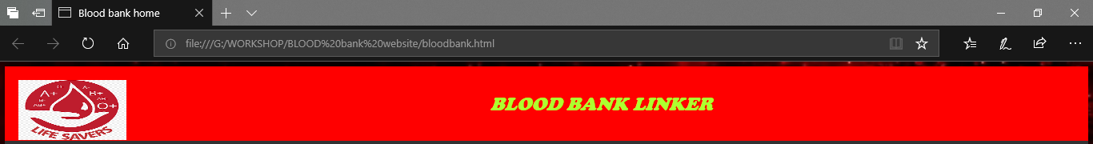

**Navigation bar:**

The <nav> tag defines a set of navigation links.

Notice that NOT all links of a document should be inside a <nav> element. The <nav> element is intended only for major block of **navigation links**.

Browsers, such as screen readers for disabled users, can use this element to determine whether to omit the initial rendering of this content.

**HTML Code**

<div class="topnav">

<a href="bloodbank.html">Home</a>

<a href="hospital_register.html">register</a>

<a href="#">Search</a>

<a href="#">Add blood</a>

<a href="#">Alternative blood info</a>

<a href="#">Contact us</a>

</div>

**CSS**

.topnav {

overflow: hidden;

background-color: #333;

}

.topnav a {

float: left;

display: block;

color: #f2f2f2;

text-align: center;

padding: 20px 20px;

font-size: 22px;

text-decoration: none;

font-family: "Cooper Black", Times, serif;

font-style: italic ;

font-weight: bold;

color:red;

}

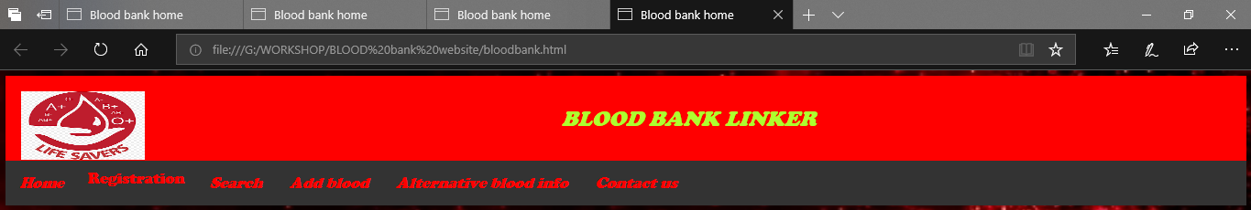

**Dropdown in navigation bar:**

Create a dropdown menu that appears when the user moves the mouse over an element inside a navigation bar.

Use any element to open the dropdown menu, e.g. a <button>, <a> or <p> element.

Use a container element (like <div>) to create the dropdown menu and add the dropdown links inside it.

Wrap a <div> element around the button and the <div> to position the dropdown menu correctly with CSS.

We have styled the navigation bar and the navbar links with a background-color, padding, etc.

We have styled the dropdown button with a background-color, padding, etc.

The .dropdown class is the container for .dropdown-content. Since this is a <div> element, and not an <a> element, we have to float it to make sure that it stays next to the links.

The .dropdown-content class holds the actual dropdown menu. It is hidden by default, and will be displayed on hover (see below). Note the min-width is set to 160px. Feel free to change this.

Instead of using a border, we have used the box-shadow property to make the dropdown menu look like a "card". We also use z-index to place the dropdown in front of other elements.

The :hover selector is used to show the dropdown menu when the user moves the mouse over the dropdown button.

**HTML Code**

<div class="dropdown">

<button class="dropbtn">Registration

</button>

<div class="dropdown-content">

<a href="hospital_register.html">Blood bank</a>

<a href="donor.html">Donor</a>

<a href="reciptor.html">Reciver</a>

</div>

**CSS**

.dropdown {

float: left;

overflow: hidden;

}

.dropdown .dropbtn {

font-size: 16px;

border: none;

outline: none;

color: red;

padding: 14px 16px;

background-color: inherit;

font-family: "Cooper Black", Times, serif;

font-size: 22px;

}

.navbar a:hover, .dropdown:hover .dropbtn {

background-color: black;

}

.dropdown-content {

display: none;

position: absolute;

background-color: #f9f9f9;

min-width: 160px;

box-shadow: 0px 8px 16px 0px rgba(0,0,0,0.2);

z-index: 1;

}

.dropdown-content a {

float: none;

color: black;

padding: 12px 16px;

text-decoration: none;

display: block;

text-align: left;

}

.dropdown-content a:hover {

background-color: #ddd;

}

.dropdown:hover .dropdown-content {

display: block;

}

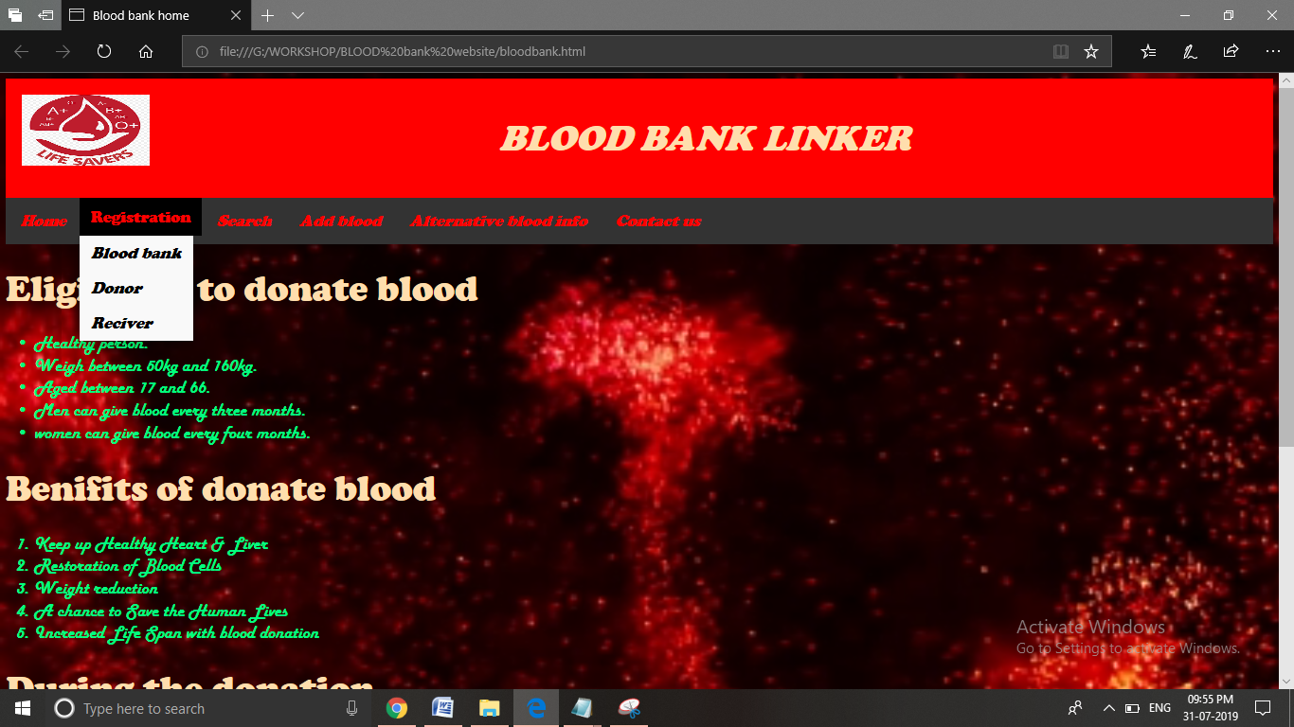

**Unordered HTML List**

An unordered list starts with the [<ul>](https://www.w3schools.com/tags/tag_ul.asp) tag. Each list item starts with the [<li>](https://www.w3schools.com/tags/tag_li.asp) tag.

The list items will be marked with bullets (small black circles) by default:

Unordered HTML List - Choose List Item Marker

The CSS list-style-type property is used to define the style of the list item marker:

|  |  |
| --- | --- |
| **Value** | **Description** |
| disc | Sets the list item marker to a bullet (default) |
| circle | Sets the list item marker to a circle |
| square | Sets the list item marker to a square |
| none | The list items will not be marked |

**Html code**

<div class="main">

<h1> Eligibility to donate blood</h1>

<ul>

<li>Healthy person.</li>

<li>Weigh between 50kg and 160kg.</li>

<li>Aged between 17 and 66.</li>

<li>Men can give blood every three months.</li>

<li> women can give blood every four months.</li>

</ul>

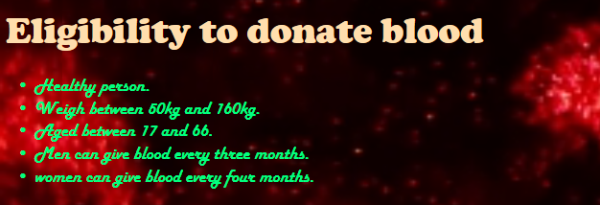

## Ordered HTML List

An ordered list starts with the [<ol>](https://www.w3schools.com/tags/tag_ol.asp) tag. Each list item starts with the [<li>](https://www.w3schools.com/tags/tag_li.asp) tag.The list items will be marked with numbers by default:

The type attribute of the [<ol>](https://www.w3schools.com/tags/tag_ol.asp) tag, defines the type of the list item marker:

|  |  |
| --- | --- |
| Type | Description |
| type="1" | The list items will be numbered with numbers (default) |
| type="A" | The list items will be numbered with uppercase letters |
| type="a" | The list items will be numbered with lowercase letters |
| type="I" | The list items will be numbered with uppercase roman numbers |
| type="i" | The list items will be numbered with lowercase roman numbers |

**HTML Code**

<h1> Benifits of donate blood</h1>

<ol>

<li>Keep up Healthy Heart & Liver</li>

<li>Restoration of Blood Cells</li>

<li>Weight reduction</li>

<li>A chance to Save the Human Lives</li>

<li> Increased Life Span with blood donation</li>

</ol>

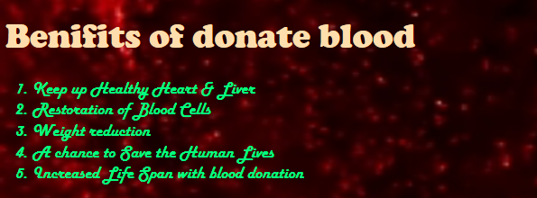

**Paragraph**

The <p> tag defines a paragraph.

Browsers automatically add some space (margin) before and after each <p> element. The margins can be modified with CSS (with the margin properties).

|  |  |  |
| --- | --- | --- |
| Attribute | Value | Description |
| [align](https://www.w3schools.com/tags/att_p_align.asp) | left right center justify | Not supported in HTML5. Specifies the alignment of the text within a paragraph |

**HTML Code:**

<h1>During the donation</h1>

<p>The donor's arm is cleaned with an alcohol prep pad, and a member of the donation team inserts a needle into a vein. The needle is brand-new and sterile.

The needle is attached to a collection tubing and bag, and the blood will flow into the bag until it is full.

According to the American Red Cross, a whole blood donation takes 8-10 minutes on average. If a person is donating a blood product, such as platelets or plasma, this process can take up to 2 hours.</p>

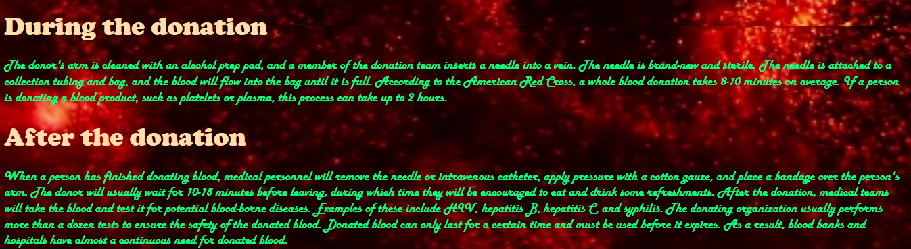

**Footer**

The footer is placed at the bottom of your page. It often contains information like copyright and contact info.

Contact information within a <footer> tag should be marked up using the [<address>](https://www.quackit.com/html_5/tags/html_address_tag.cfm) tag

**HTML Code**

</div>

<div class="footer">

<p>Donate Blood to Save Life!</p>

</div>

**CSS**

.footer {

background-color: #ff0000;

padding: 10px;

text-align: center;

}



**CSS for Body**

body{

background-image:url("back.jpg");

background-repeat: no-repeat;

background-size: cover;

color: #00FF7F;

font-size:25px;

font-family: "Harlow Solid Italic", Times, serif;

}

**CSS Font Families**

In CSS, there are two types of font family names:

* **generic family** - a group of font families with a similar look (like "Serif" or "Monospace")
* **font family** - a specific font family (like "Times New Roman" or "Arial")

## Font Family

The font family of a text is set with the font-family property.

The font-family property should hold several font names as a "fallback" system. If the browser does not support the first font, it tries the next font, and so on.

Start with the font you want, and end with a generic family, to let the browser pick a similar font in the generic family, if no other fonts are available.

**Font Style**

The font-style property is mostly used to specify italic text.

This property has three values:

* normal - The text is shown normally
* italic - The text is shown in italics
* oblique - The text is "leaning" (oblique is very similar to italic, but less supported)

**Font Size**

The font-size property sets the size of the text.

Being able to manage the text size is important in web design. However, you should not use font size adjustments to make paragraphs look like headings, or headings look like paragraphs.

Always use the proper HTML tags, like <h1> - <h6> for headings and <p> for paragraphs.

The font-size value can be an absolute, or relative size.

**Absolute size:**

* Sets the text to a specified size
* Does not allow a user to change the text size in all browsers (bad for accessibility reasons)
* Absolute size is useful when the physical size of the output is known

**Relative size:**

* Sets the size relative to surrounding elements
* Allows a user to change the text size in browsers
* All CSS Font Properties

|  |  |
| --- | --- |
| Property | Description |
| [font](https://www.w3schools.com/cssref/pr_font_font.asp) | Sets all the font properties in one declaration |
| [font-family](https://www.w3schools.com/cssref/pr_font_font-family.asp) | Specifies the font family for text |
| [font-size](https://www.w3schools.com/cssref/pr_font_font-size.asp) | Specifies the font size of text |
| [font-style](https://www.w3schools.com/cssref/pr_font_font-style.asp) | Specifies the font style for text |
| [font-variant](https://www.w3schools.com/cssref/pr_font_font-variant.asp) | Specifies whether or not a text should be displayed in a small-caps font |
| [font-weight](https://www.w3schools.com/cssref/pr_font_weight.asp) | Specifies the weight of a font |

## Images tag

In HTML, images are defined with the <img> tag.

The <img> tag is empty, it contains attributes only, and does not have a closing tag.

The src attribute specifies the URL (web address) of the image:

## The alt Attribute

The alt attribute provides an alternate text for an image, if the user for some reason cannot view it (because of slow connection, an error in the src attribute, or if the user uses a screen reader).

The value of the alt attribute should describe the image:

**Background image**

**CSS syntax:**

<body style="background-image:url(bgimage.jpg)">

**HTML Code**

body{

background-image:url("back.jpg");

background-repeat: no-repeat;

background-size: cover;

}

Background image:



**Form**

The <form> tag in HTML is used to create form for user input. There are many elements which are used within form tag. For example: <input>, <textarea>, <button>, <select>, <option>, <optgroup>, <fieldset>, <label>.

**Syntax:**

<form> Form Content... </form>

**Attributes:** There are many attributes which are associated with <form> tag. Some of them are listed below:

* **input:** It is used to specify the input field for user.
* **textarea:** It is used to specify for multi-line text input field for user.
* **button:** It is used to perform an operation in a form by the user.
* **label:** It is used to give label to any tag like button, input etc.

|  |  |
| --- | --- |
| **Attribut** | **Description** |
| accept-charset | Specifies the charset used in the submitted form (default: the page charset). |
| Action | Specifies an address (url) where to submit the form (default: the submitting page). |
| autocomplete | Specifies if the browser should autocomplete the form (default: on). |
| Enctype | Specifies the encoding of the submitted data (default: is url-encoded). |
| Method | Specifies the HTTP method used when submitting the form (default: GET). |
| Name | Specifies a name used to identify the form (for DOM usage: document.forms.name). |
| novalidate | Specifies that the browser should not validate the form. |
| Target | Specifies the target of the address in the action attribute (default: _self). |

**Input Tags:**

* **input tag:** It is used to take the input from the user.

|  |  |
| --- | --- |
| **Type** | **Description** |
| <input type="text"> | Defines a one-line text input field |
| <input type="radio"> | Defines a radio button (for selecting one of many choices) |
| <input type="submit"> | Defines a submit button (for submitting the form) |

## Dropdown list:

## The <select> Element

The <select> element defines a **drop-down list**:

It is used to select an option froma drop-down list.

Syntax:

* <option> Statements ... <option>
* The <option> elements defines an option that can be selected.
* By default, the first item in the drop-down list is selected.
* To define a pre-selected option, add the selected attribute to the option:
* Use the size attribute to specify the number of visible values:

**HTML Code**

<select style="color:red;background-color:#99FFFF"required>

<option value="">Select Blood Group</option>

<option value="A1+">A1+</option>

<option value="A1-">A1-</option>

<option value="A2+">A2+</option>

<option value="A2-">A2-</option>

<option value="B+">B+</option>

<option value="B-">B-</option>

<option value="A1B+">A1B+</option>

<option value="A1B-">A1B-</option>

<option value="A2B+">A2B+</option>

<option value="A2B-">A2B-</option>

<option value="AB+">AB+</option>

<option value="AB-">AB-</option>

<option value="O+">O+</option>

<option value="O-">O-</option>

<option value="A+">A+</option>

<option value="A-">A-</option>

</select>

<select style="color:red;"required>

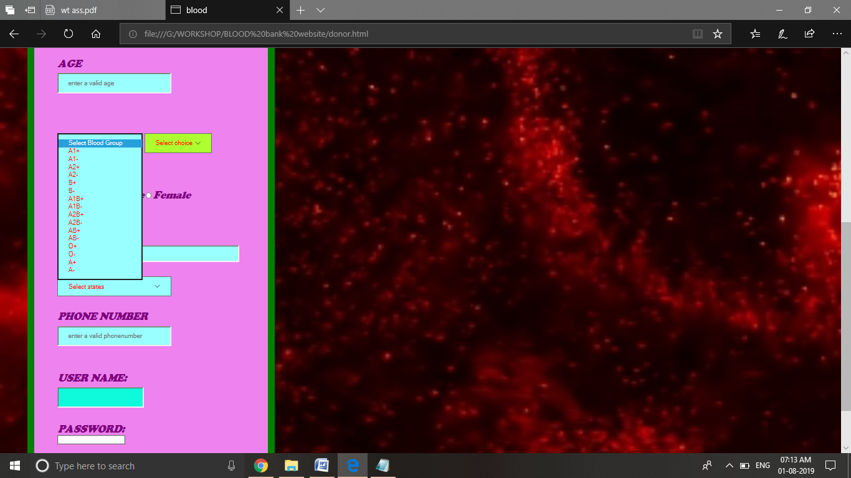

**Radio Button:**

 It is used to select only one option from the given options.

Syntax:

* <**input** type="radio" name="option"> Option 1
* The <br> tag in HTML is used to give the single line break. It is the empty tag so it does not contain end tag.

**HTML Code:**

<p><b>

GENDER:

</b> <input type ="radio" name ="gender" value ="male"required>

<b>Male</b>

<input type ="radio" name ="gender" value ="female"required>

<b>Female</b> </p>

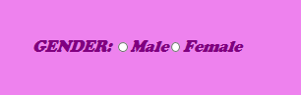

**Text Area**

 The **HTML** <**textarea**> **tag** is used within a form to declare a **textarea**element - a control that allows the user to input text over multiple rows.

* <textarea rows="" cols="">  
   Content.....  
  </textarea>

**HTML Code:**

<p> <b> ADDRESS</b><br>

<textarea

row = "8"

cols =50"

input type= "text"

required placeholder = "enter a valid address"

style="background-color:#99FFFF">

</textarea> </p>

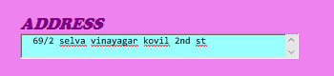

**CSS Box Model**

All HTML elements can be considered as boxes. In CSS, the term "box model" is used when talking about design and layout.

The CSS box model is essentially a box that wraps around every HTML element. It consists of: margins, borders, padding, and the actual content. The image below illustrates the box mode:

Explanation of the different parts:

* **Content** - The content of the box, where text and images appear
* **Padding** - Clears an area around the content. The padding is transparent
* **Border** - A border that goes around the padding and content
* **Margin** - Clears an area outside the border. The margin is transparent

**CSS**

form{

background-color: #EE82EE;

width: 400px;

border: 15px solid green;

padding: 50px;

margin: 50px;

}

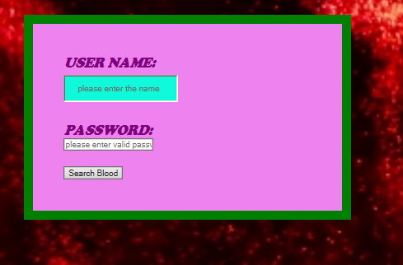

**Complete Output for a project:**

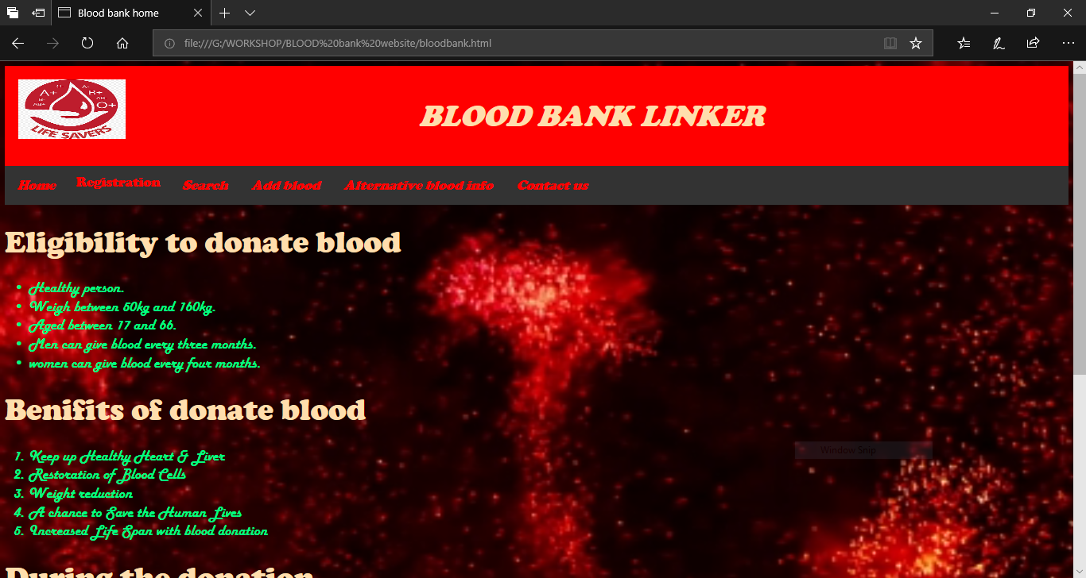

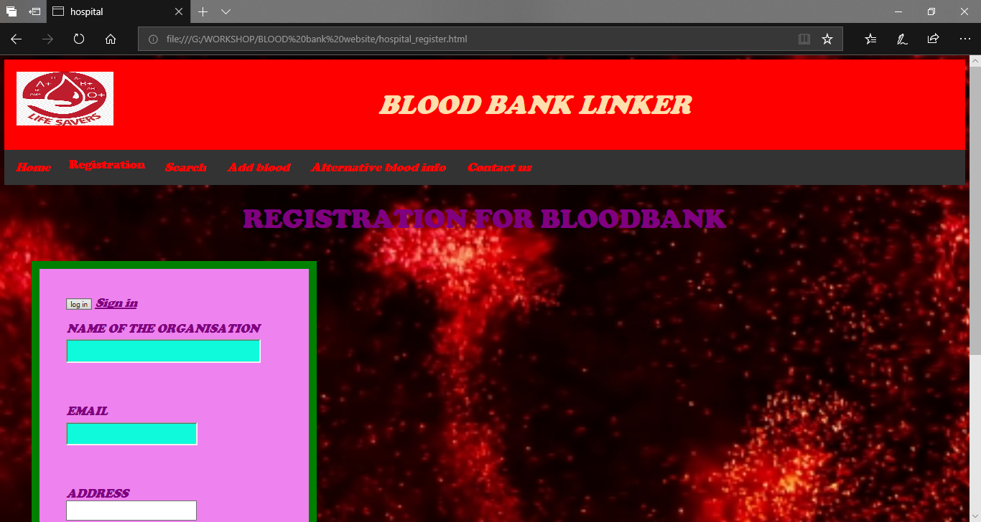

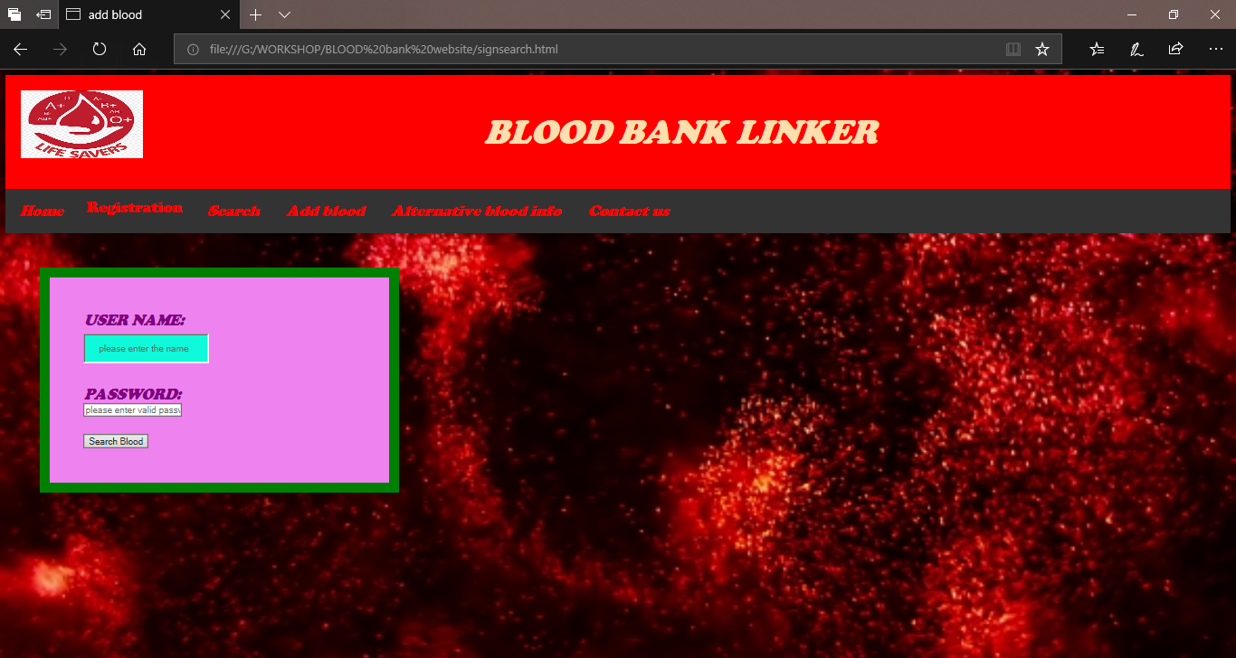

**Result:**

Thus the UI design of the blood bank management syatem is created with brief description of all html tags